Appearance & Interface Description

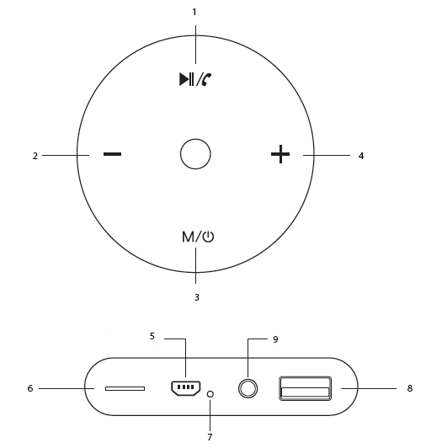

  - Multi-Function Button
  - Volume –
  - Power Button
  - Volume + (Next Track)
  - Power Input
  - TF Card Slot
  - LED Indicator
  - AUX-In Port
  - USB Media Input
Operation Instructions
- Turning Boom-10 On/Off
- Press and hold the power button to turn on/off the speaker.

- Pairing Boom-10
- The speaker enters Bluetooth mode automatically when turned on.
- Turn on the Bluetooth function of the device you wish to connect and search for “Promate Boom-10”. From the list of found devices, select “Promate Boom-10”.
- Boom-10 will pair automatically with the last connected device.

- Using TWS Function
  - Turn on both speakers and ensure they are in Bluetooth mode.
  - Long press the Multi-Function button on both speakers until you hear a tone.
  - You will hear a tone once both speakers to pair with each other.
  - Once paired, you may pair your device to the speakers using the above-mentioned steps.

- USB & TF Card Function
- Insert the USB media device or TF card into the USB port or TF Card Slot.
- Boom-10 will automatically start playing music files from the USB port or TF Card Slot.
- Control music playback using the Volume Buttons.

- Controlling Music Playback
- Music Play/Pause: Press the multi-function button once to play/pause music tracks
- Music Track Control: Short press the Volume + or Volume – buttons to skip to the next or previous track.
- Volume Control: Long press the Volume + or Volume – buttons to increase or decrease the volume.

- AUX Function
- Connect your playback device via the AUX port to Boom-10.
- Press the Multifunction Button to enter AUX mode.

Troubleshooting
- Boom-10 does not pair with a Bluetooth device:
- Check if the Bluetooth hardware on your device supports A2DP profile which is necessary for sound transmission over Bluetooth.

